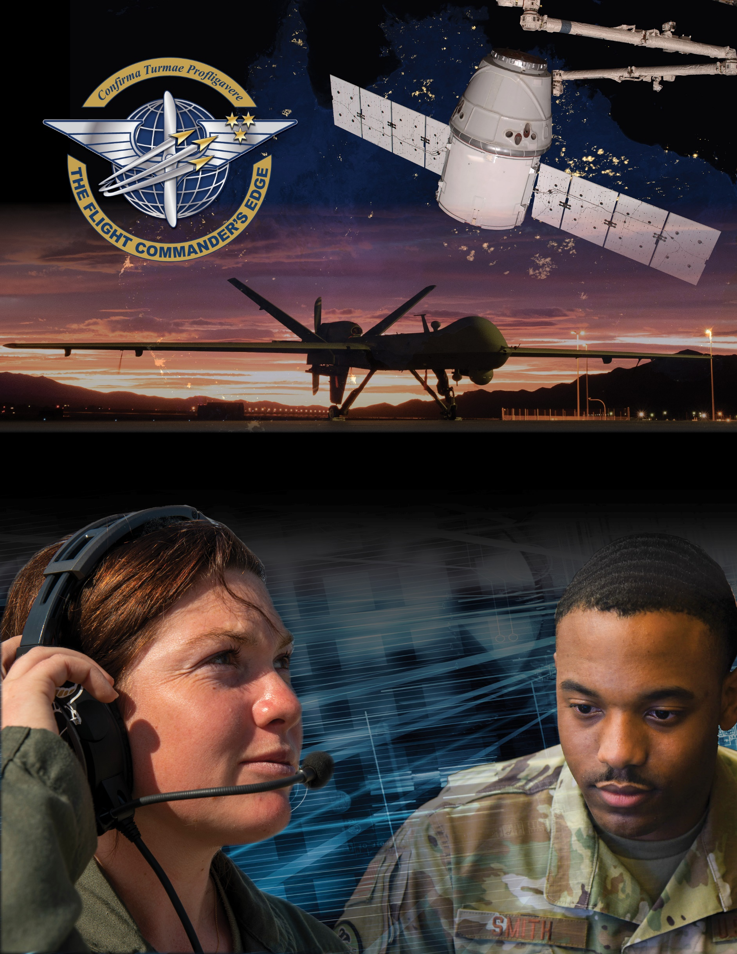

**Lesson Guide**



**Material Management**

***14 April 2025***

**Materiel Management**

### Purpose

This lesson guide is designed to support the local development of Flight Commander Leadership Course materials. Selected facilitators should use this guide as they prepare presentation materials. For more information on how lessons are structured, or how to use them in the course, see the ***Course Director’s Handbook*** or online Facilitator Resources.

### Scope

The goal of the Department of the Air Force’s Materiel Management Program is to ensure the warfighter receives the right support at the right place and the right time. Base Logistics Readiness Squadrons (LRS) play a major role in materiel management for their customers. It is important for leaders at all levels of command to be familiar with the role of the local LRS.

Materiel consists of certain equipment (engines, munitions, electronics, and weapon systems and sub-systems) that some flight commanders will have to manage daily in order to accomplish the mission effectively, staying budget-conscious and aware of life cycles at all times. Flights such as those in Operations, Maintenance, Cyberspace, and Mission Support units will have a significant materiel footprint, while others may have a minimal footprint. Regardless of the amount of materiel for which you are responsible, you must manage it effectively, stay updated on the materiel needs of your flight, and justify funding of required items when needed.

### Recommended Objectives

By the end of this lesson, the participant should be able to:

1. Describe the importance of accurate accountability and status of materiel in your flight.
2. Explain how Life Cycle Management Program affects materiel in your flight.
3. Discuss the role the local LRS plays in supporting your flight.

### Recommended POC / Presenter

* Logistics Readiness Squadron representative
* Squadron-level leader (DO, CC or equivalent)

### Recommended Length:

* 25 minutes (inclusive of questions)

### Recommended Approach

* Present informational slides with Q & A

### Lesson Connections

* **Mission Command-**managing materiel is characterized by constrained resources. Therefore, Flight Commanders must earn their commander’s trust and make decisions aligned with their commander’s intent.
* **Organizational Structure and the Mission-**materiel requirements are directly driven by mission requirements. Flight Commanders must clearly recognize this relationship to properly manage materiel.
* **Funding-**the alignment of funding with materiel drives crucial considerations and prioritization for many units.

**Additional Discussion**

A robust networking relationship between the Flight Commander and the LRS can be especially important when managing materiel.